Classification of Insects

➢ Any organism which causes economic damage to the crops or interferes with the welfare
of human beings or his belongings.
➢ Pest is derived from term “pestis” which means plague.
➢ Generally, any organism which causes irritation to the other organism.
❖ EXOSKELETON
➢ The exoskeleton not only provides a larger area for the attachment of muscles but also
protects muscles from mechanical injury.
➢ It affords excellent mechanism to protect insects against desiccation.
➢ In some insects, the exoskeleton has turned appendages into good tools for digging,
preying, oviposition etc.
➢ The exoskeleton maintains the shape of the body much more efficiently than
endoskeleton.
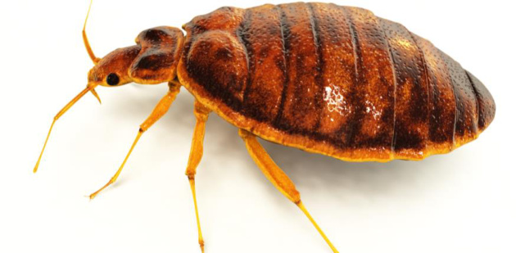

❖ FUNCTIONAL WINGS
➢ It has increased the feeding and breeding range and provided a new means of eluding
enemies of attacking a fast-moving host and of finding a mate.
➢ Increasing feeding range undoubtedly opened the way for the adoption of specific food
especially in those areas in which the host or breeding medium occurred in small
quantities and in scattered situations.
➢ E.g., Mosquitoes, which without wings would not have been able to breed in small pools
of water which dry in a short time.
➢ Intercontinental migrations in locusts and butterfly are very common.
❖ HEXAPOD LOCOMOTION:
➢ Jointed nature of legs is a characteristic which insect share with their other Arthropod
allies, but the number of such legs has undergone an ideal stage of evolution in insects.
➢ Six legs in insects represent the optimum number which no other group of animals has hit
upon.
➢ The large no. of legs as in millipedes is bound to make the locomotion rather
cumbersome but when the number of walking legs become less than six, it is bound to
create a problem of balancing during locomotion.
➢ Thus, six is the smallest number for a stable equilibrium during all stages of terrestrial
locomotion.
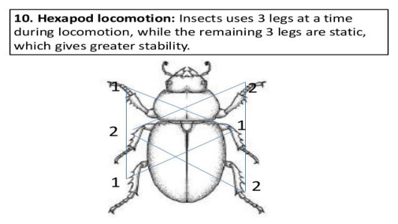

❖ COMPOUND EYES
➢ Insects usually have a pair of compound eyes in nymphal and adult stages and in addition
sometimes simple eyes too.
➢ Their eyes are called compound because each eye instead of having a single large cornea,
consists of a number of hexagonal areas each representing the cornea of a discrete visual
organ called the ommatidium all of which are compacted together.
➢ E.g., Ants have 50-400 facets or corneas in each eye, the housefly -4000 dragonfly >
50,000. It is obvious that the insect will not lose this power of vision completely if a few
of their ommatidia are injured.
❖ Scattered sense organs
➢ Except the eyes, none of the other sense organs are invariability concentrated on the
head. The organs of hearing are sometimes located on the antennae.
➢ Similarly, the organs of taste and smell may occur on the antennae, mouth parts, or even
on the tarsi or cerci. Such diffused and scattered nature of sense organs are bound to be
advantages to insects as the arrangement reduces the chances of all receiving injury at the
same time.
❖ Decentralized nervous system
➢ The central nervous system is a ladder like chain of ganglia along the ventral side of the
body except one is also dorsal to alimentary canal.
➢ This system is so decentralized that brainless insects can be artificially stimulated to
walk, fly or even feed and according to some, the living abdomen of the female silkworm
moth when separated from the thorax can be fertilized by the male and stimulated to lay
fertile eggs.
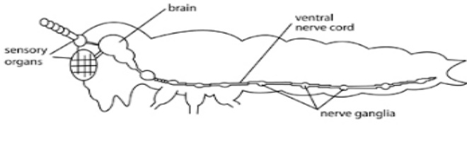

❖ Direct respiration
➢ This important physiological function is independent of the mediation of blood which in
insects is not required to transmit the gases of respiration.
➢ These gases are taken to and fro every minute part of the system directly through
air tubes called trachea and tracheoles which have several openings called spiracle
rather than a pair of nostrils.
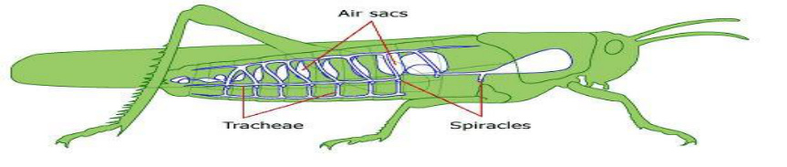

❖ Enteronephric excretion
➢ The excretory function is performed by Malpighian tubules, which open into the front
part of hind intestine instead of opening directly to the exterior. Also, the excretory
products are semisolid rather than liquid urine.
➢ Predators are free-living species that directly consume a large number of preys during
its whole lifetime.
➢ Ladybird beetles, specifically their larvae are active predators on aphids, and mites,
scale insects and small caterpillars.
➢ Dragonflies are important predators of mosquitoes.
➢ Parasitoids lay their eggs on or in the body of the insect host, which is then used as food
for the developing larvae.
➢ Most parasitoids are wasps and flies, and usually have a very narrow host range.
➢ Each insect species has essential nutritional requirements for the completion of its life
cycle.
❖ Based on nutritional requirements, the insects are classified as below
1. Carnivorous: They feed and live on other animals as parasites and predators.
2. Omnivorous: They feed on both plants and animal such as wasps.
3. Herbivorous: They use living plants as their food such as various crop plants.
❖ The insect of this category is further classified as-
➢ Monophagous: The insect which feed on a single species of plant. E.g., Brinjal fruit
borer, Pink boll worm in cotton.
➢ Oligophagous: In this case the feeding activities of a particular species of insects are
confined only to a plant of one botanical family. E.g., Cabbage butterfly, mustard saw
fly.
➢ Polyphagous: The insect which feed on various types of cultivated and wild plants. E.g.,
Bihar hairy caterpillar, Gram pod borer, Locust, Grasshopper etc.
❖ Economic importance of insects
➢ All insects are not harmful, those harmful are not harmful unless their number cross
certain limit.
➢ Economic importance of insects lies more in their harmful effects than beneficial effects.
➢ Higher the status of an insect as pest, more important that insect is.
❖ Beneficial effects:
a. Insects of industrial importance:
➢ Honeybees: Honey, beeswax, bee venom, royal jelly, propolis and Pollination
➢ Silkworm: Silk
➢ Lac insect: Shellac
b. Pollination: Transfer of pollens from anthers to stigma
➢ Insect Pollinators: Honeybees (75-80%), butterflies, flies, beetles, thrips, etc.
c. Entomophagous insects:
(i) Predators:
➢ Coccinellids (Coleoptera): e.g., Coccinella septempunctata, Hippodamia variegata,
Menochilus sexmacula, etc.
➢ Syrphids (Diptera): e.g., Episyrphus balteatus, Metasyrphus corrollae, Scaeva pyrastri
➢ Chrysopids (Neuroptera): e.g., Chrysoperla carnea
➢ Predatory bugs (Heteroptera): e.g., Anthocoris minki, Orius spp
➢ Preying mantids (Dictyoptera): e.g., Statilia maculata
➢ Predatory wasps (Hymenoptera): e.g., Vespa spp
(ii) Parasitoids:
➢ Egg parasitoid: e.g. Trichogramma spp.
➢ Larval parasitoid: e.g., Cotesia (Apanteles) spp., Bracon sp.
➢ Egg-larval parasitoid: e.g., Chelonus blackburni,
➢ Larval-pupal parasitoid: e.g. Ceromosia auricaudata (Diptera: Tachinidae)
➢ Pupal parasitoid: Brachymeria nephontidis on Earias spp
➢ Adult parasitoid: Blaesoziphae kellyi
➢ Egg parasitoid: attacks egg stage of the host. Example- Trichogramma chilonus, T.
preteosum, Ooencyrtus sp. a true egg parasitoid of various lepidopterous pests.
➢ Egg Larval Parasitoid: Another category of egg parasitoids, which deposits eggs in the
host eggs, but development and emergence are not completed until the host larval stage is
reached. e.g., Braconid, Chelonus annulipes on European corn borer, Chelonus
blackburni on PTM and bollworm, Capidosoma koehleri on PTM.
➢ Larval Parasitoids: True larval parasitoids are those parasitoids which deposit egg on
the larvae and their progeny complete development and emerge from the host larvae. e.g.,
Apanteles spp. On pink bollworm, Bracon brecicornis on spotted boll worms.
➢ Pupal Parasitoid: Parasitoids that deposit their eggs in the host pupae and emerge from
the host pupae. e.g., Brachymeria nephontidis on Earias spp. All Chalidae (Hymenoptera)
are pupal parasitoids.
➢ Adult Parasitoids: Parasitoids of adults hosts. The parasitoids deposit a larva on its host
while in flight and the mature maggot emerges from the dead adults host.’ e.g.,
Blaesoziphae kellyi a parasitoid of locust.
➢ Nymphal Adult Parasitoids: The parasitoids deposit their eggs on/in host nymph and
emerge from the dead adult host. e.g., Epiricania melanoleuca parasitic on Pyrilla
perpusilla.
➢ Nymphal Parasitoids: The parasitoids deposit eggs on nymphs and their progeny
complete development and emerge from the host numphs. e.g., Epipyrops fuliginosa on
nymphs of Idioscopus clyealis.
d. Nutrient cycling:
➢ Detritus and dung feeders e.g., Termites, dung beetles etc.
e. Human food:
➢ Over 500 spp. like crickets, grasshoppers, beetles, caterpillars, termites are used as food
by human beings in different parts of the world.
f. Aesthetic value:
➢ Brightly coloured butterflies and beetles are used for various decorations
❖ Harmful effects:
➢ Only a few species (0.01%) are harmful and attain the status of pest.

